Manatee Elementary 5th Grade Science Fair Guide

Students, this guide is designed to help you while working on your project at home – please read all the way through before beginning your project, then revisit each section as you work, to ensure accuracy. This guide, teacher guidance and instruction, and, most importantly, your effort level, will help you successfully complete a science fair project.

Please take note of the following rules and restrictions:
- You must write everything in ink – no pencil or typing allowed in your logbook. (typed copies will go on your science board once the project is completed)
- You are required to keep a logbook in a binder. No loose papers will be accepted at any point.
- ALL measurements have to be in METRIC UNITS!
- Research and a bibliography are required for all Fifth Grade projects. Research must be completed before making your hypothesis and should be included in forming the hypothesis.
- Your project must be a controlled experiment: something must be tested and compared through measurements and data must be collected.
- Objects and pieces of your experiment will NOT be permitted to be shown with your project or glued on the board (per county regulations).
- Project must fall under one of the following categories: biological, physical, environmental, or engineering.
- Projects about cleaning pennies, floating eggs in salt water, testing paper towel strength/absorbency, popping popcorn, or gummy candy absorbency are not considered fifth grade level science and will not be approved.
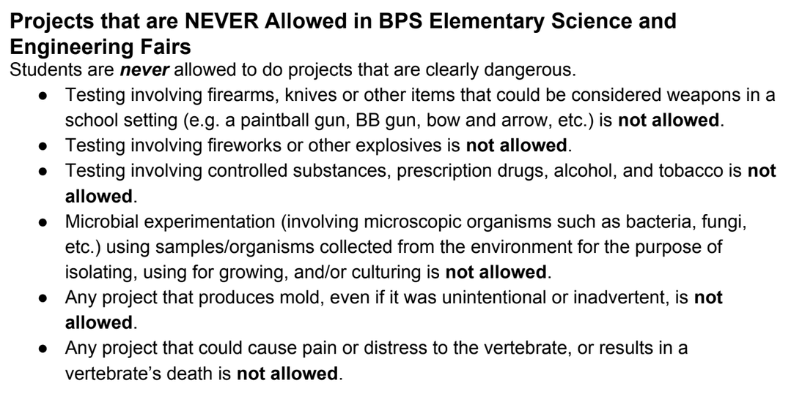

Please contact your classroom science teacher if you have any questions throughout the project.

Have fun: your goal should be to learn something new with your project!

Question & Title

The purpose of this Science Fair Experiment is to try and find the answer to a question you have, by conducting a controlled experiment (answers can’t be ‘yes’ or ‘no’).
This is NOT a research project (“Hearts: how do they work?) and this is NOT a time to make a model (This is how a volcano erupts)… think of it as solving a problem.
Make sure it is something you can test, measure and collect data.

**do not begin your experiment until your question has been approved**

My Experiment Question: ______________________________________________________________________________

______________________________________________________________________________

Why is this question important to you?
_______________________________________________________________________
_______________________________________________________________________
How do you plan to test this question? ____________________________________________________________________________________________________________________________________________________________What will you measure? How will you measure it? ____________________________________________________________________________________________________________________________________________________________
The title of your project may be the same as your experiment question above. However, to have a more “catchy” title will grab the judges’ attention to your display board and might keep their interest on your project longer.

My Catchy Science Fair Title:

_____________________________________________________________________________

Teacher approved for testing ______________

Daily Log & Observations

Your daily log should begin from the very 1st day of your project and kept in your binder. Each part of your project will be recorded as though it were a “science fair diary” every time you work on your project (don’t forget to write in ink!).

Set up three sections in your binder, using tabs:

Section One will be your research – find at least three reliable print or online sources and write about what you learn about what is already known related to your topic (do not copy, write notes in your own words). Keep track of all sources and websites for your bibiliography, which should be completed at the same time as the research. You will use this research to develop your hypothesis. Research should be a minimum of 2 full pages, handwritten.

Section Two will be your project notes: this includes everything you are learning and doing for your project. The question, title, hypothesis, materials & procedures, and variables will go here, along with your reflections and experiences throughout your project. This part of the project should be several pages long and include many details.

Section Three is where you will record data as you collect it, on a data table. After the data has been collected, you will create a graph, and analyze the data to write your results and conclusion in this section.

Remember to date each entry, every time you write in your logbook.

** you are responsible for daily entries**
nOTE: Some projects can be tested and retested several times in one or two days. The term “daily” log may not mean many days. However, your log should include what you did to research and all parts of your project in detail.

Step 1: Ask a Question

Look up things that are interesting to you and you wonder about to come up with a question. Try to find something that is meaningful and matters to people. Your question must be something that can be tested to measure changes (in metric measurements) and compare results. Later, your measurements will be put into a graph, so think ahead about how you will graph it.

Step 2: Research
Your research must be written in ink in the first section of your notebook. Aim for at least 2 or more full pages of notes to be adequate. This is a very important (and required) part of the project because it should be used to help you form your hypothesis. You must do research and not rely on what you already think you know. Look for information you did not know before. Take notes and then summarize the information in your own words. Copying from a source is not permitted.
You should use at least 3 different reliable sources in your research (Wikipedia is not a reliable source and is not accepted). Remember, you can use books, as well as the internet.
**A bibliography is required for 5th and 6th grade students**
Make sure you record all of the book’s or website’s information (title, author, date/city published, etc) to include in your bibliography as you gather information. DO NOT attempt to go back and find sources again later – it may be very difficult to retrace your steps through a websearch.
Using www.easybib.com makes building a bibiliography very easy. You can enter sources as you use them and save it as you go. Print at the end and it formats the bibliography automatically for you.

STEP 3: HYPOTHESIS
Your hypothesis is an educated guess as to what will happen by the end of your investigation. This guess should be based on your research and you should have background information to support your predicted answer.
Your hypothesis should be written in an “If…..then…because….” statement.

Example: “If I _______ (tell what are going to do or test in your project) then _______ (what you think will happen) because _______ (tell a reason you think this will happen based on your research).”
If I plant Marigold seeds and water one with tap water, one with distilled water, and one with well water, then the one with well water will grow the tallest because of all the minerals in well water that help plants grow.

You would not just say, “I think that plants grow better with water.” You would need to explain why you think so. Did you read a book about plants? Search the internet for some background information on plants? You need to give a reason for how you came up with that hypothesis.
**Remember: your hypothesis does not change once it is made!

StEP 4: Conduct Your Experiment

- If you are going to have subjects taste test or eat anything, you must turn in “Informed Consent” forms for each test subject. You can get these from Manatee’s website, or your teacher.

CONTROLLING VARIABLES
It is important that you complete your experiment with only one independent variable (ie. same seeds, location, and soil… just changed the type of water) and do at least 5 repeated trials (ie. grow 5 marigold seeds for three types of water = 15 plants total) to make sure your results are valid and accurate and for back up in case one try doesn’t work. Think carefully about all the variables you need to control – this will guide your materials list and steps of your procedure. Identify the variables in your logbook.

- Independent Variable The one variable you are changing to make something happen.

- Dependent Variable The variable that you will record and measure to see if there was a change. The changes “depend” on the independent variable and are what you are trying to make happen.

- Controlled Variables All the aspects of this experiment that must remain constant to make sure the test is fair and unbiased.

- You might also need a Control Group, to which no changes are made from what is ‘normal’, for comparison.

Repeated Trials
You must conduct the experiment to show at least 5 trials. You may have 5 or more trials going on at one time, or do them one after the other. Do what works best for your experiment. The more often you run your experiment, the more reliable your results will be.

Materials & Procedure
Write a detailed list of ALL materials that you will need or use during this project. Be very specific about what you used in your investigation. All supplies and tools MUST be listed in METRIC UNITS!!
A Good List A poor list
500mL potting soil tap water ruler (mm) Dirt
15 clay pots mineral water Pots
15 marigold seeds well water Water

Materials & Procedure, continued
An experiment is like a recipe. How did you do your investigation? What did you do first, next, after that? Make it clear enough so that the judges will know exactly what you did and other scientists could follow it accurately. List everything you did in numbered steps. Put down the amounts, time involved, and measurements (IN METRIC UNITS!), number of times you will test (trials)… include even the smallest details. Someone should be able to follow your procedure and conduct exactly the same experiment as you did, so make it detailed.

COLLECTING DATA
Set up a table (Section 3), BEFORE EXPERIMENTATION, in your Daily Log to record your data as you collect it during your project. Record data and observations as soon as you have them to make sure everything is accurate. Don’t rely on your memory and write it later on! DON’T FORGET, MEASUREMENTS MUST BE METRIC.
Data Table
 | Beginning Temp | 1 | 2 | 3 | 4 | 5 | 6 | 7 | 8 | 9 | Difference in temp from beginning to end
Shingle
Brick
Metal
Control
Temperature for trials in Degrees Celsius

DISPLAYING DATA
https://nces.ed.gov/nceskids/createAgraph/
Use the data from your data table and put it into a graph form which others can easily understand. You will need to create a line, circle, or bar graph, depending on what kind of data you collected.

There are many ways to create a graph available online if you want to search for them. “Create a Graph” is a good one, but you may use anything you’d like. Be sure to label and include measurements on each axis. Include one in your daily log and print one for your board.

STEP 5: WRITTEN RESULTS
Your data has been put into a format that is easily understood on the graph. Use specific terms and details in a paragraph to analyze and explain what your graph means/shows. Are there patterns? Trends over time? One group stronger? Faster? More? Talk about the numbers! Try to use mathematical terms such as mean, median, mode and range.

For Example:
In my trials, 1 identified 29 out of 50 (58%) jelly bean flavors correctly. I had the most success identifying the Passion Fruit (90%) and the Chocolate (80%) flavors correctly. I struggled to identify the Baja Lime (30%) and the Sour Apple (30%) correctly. Volunteer 2 had the most success with Baja Lime, Passion Fruit, and Chocolate. He struggled the most with Sour Apple. Overall, he was able to identify 37 out of 50 (74%) correctly.

Include both data and observations.

STEP 6: CONCLUSION
Write about what you learned from your experiment: what can you conclude from your results. Did the data support the hypothesis? Why? If not, why do you think it did not? What would be done differently next time? Or what would you test next based on these results?

Do not worry about negative results, or results that come out differently than expected. This happens in science! Just explain why you think you got those results. If the results turned out as expected, explain why you think it turned out this way.

For example:
In my project (explain what happened- the results) ___________. My hypothesis was _______The data (did/did not) support my hypothesis. I thought ____________________ was going to happen and ________________________ happened. I think this happened because _____________________________________________________. If I were to do this project again I would change _________________________________________________ because _____________________________________________________________________________.

One Page Summary

The summary needs to be typed and put in a page protector to be included with your logbook. Put the title of your project on the summary, but do not include your name. The summary is a wrap-up of the entire project. It should be very comprehensive and complete. It can be written in 5 paragraphs.

Paragraph 1: Tell what the question was and why you chose this topic. Include at least 3 pieces of important information you learned while researching.
“My question is _______? I decided on this project because_______. I started asking questions and found out that_____________”

Paragraph 2: Tell the hypothesis and explain why you thought this would happen. Use information you collected in your research and your background knowledge to explain why you thought what you did.
“My hypothesis was ____________. I thought this would be true because_________.”

Paragraph 3: Tell how you tested the hypothesis. Do not tell the step-by-step procedures, just explain the experiment. Tell how many times you repeated the tests. Mention the variables you controlled to make sure the testing was fair. Describe the difference between the control group and experimental group.
“I tested my hypothesis by ________________. To make sure the experiment was fair, I _________.”

Paragraph 4: Tell about your results. Include some of the most important data such as totals and averages of measurements. You should also mention one or two of your most important or unusual observations.
“While doing my science project, I observed that _______. Also _______. Another interesting thing that happened was _______.”

Paragraph 5: Tell about your conclusions. Say whether or not the data supported the evidence. Tell about the most important thing you learned. Tell how people in general (or scientists) might apply this information to everyday life. If you could do this project over again, what would you do different?.
“My data (did or did not) support my hypothesis. The most important thing I learned was ____. My results show _____. This information can be used by _____. If I were to do this project over again, I would _____.

Now, all the hard work is done and you are ready to share your results with others. Follow the diagram below to create your Science Fair Board – items must be placed in the specific places as shown.

Rules for the Board
- Nothing on the board that is thicker than paper (no foam stickers or anything 3-D).
- If you include photographs, you need to include photo credit (Photo Credit to Participant, Participant’s Parent, Google Images, etc).
- Your name DOES NOT go anywhere on the board.

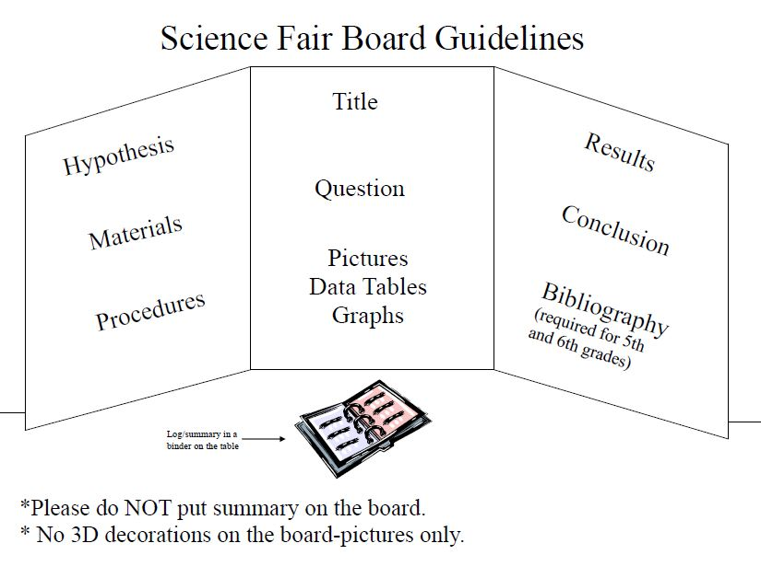
Logbook

Bibliography – required for fifth and sixth graders
www.easybib.com

- This is an alphabetical listing of all books, articles, people, interviews, websites, etc. used as resources during the investigation. Take note of and copy the formats for each specific source below (ALL punctuation is an important part of the bibliography!) if you are hand writing your bibliography. Or use EasyBib and let them do all the formatting work (in this case you do not have to also handwrite the bibliography).

Book by single author
Day, R. A. (1994). How to write and publish a scientific paper. (Fourth Edition).
Phoenix, AZ: The Oryx Press.

Book by more than one author
Cothron, J. H., Giese, R. N., & Rezba, R. J. (1993). Students and research.
(Second Edition). Dubuque, IA: Kendall/Hunt Publishing.

Computer Program
Dombeck, R. A. (1991). Theoretical prediction of interference loading on aircraft stores. (Computer program).
Ponoma, CA: General Dynamics, Electro Dynamics Division.

Encyclopedia
Photosynthesis and plants. (1987). Encyclopedia Americana (Volume 22).
New York: Americana Corporation.

Interview
Borski, S. A. M. (1985, October, 23). Arlington Heights, IL: Northwest Community Hospital. (Interview).

Journal/Magazine/Newspaper
Bonkalski, J. (1991, February). My view of the land fill. Better Homes and Gardens. pp. 52-53.
Journal/Magazine/Newspaper - no author
Study finds free care used more. (1989, May). APA Monitor. p. 14.

For an Internet Source with an author:
Author's last name, first name. "Title of Work". address (day month year).
Ogawa, Roann. "Great Lakes Science
Center". http://www.glsc.nbs.gov/science/communication/index.htm
(25 Sept. 1997)
For an Internet Source without an author:
"Electricity and Magnetism". http://www.essex1.com/people/speer/elect.html
(11 July 1996)

